GVPT 729a: Special Topics in Quantitative Political Analysis, Advanced MLE
Problem Set 4
Michael J. Hanmer

1. Answer the questions below based on the following information and the following table.
Data: 2004, individual level U.S. survey data
Method: Logit
Dependent Variable: Voted or not
Independent Variables: age (coded 18-92); highest level of education (coded in 4 categories:
1 = 0-11 years, 2 = 12 high school graduate, 3 = some college(including 2 year degree), 4 = college degree or higher); state allows early voting, i.e. voters can vote prior to election day at select locations) (1=Yes, 0=No)
Table 1. Probability of Voting in 2004
Independent Variables | Coefficient | Std. Error | Z value | p value
Constant | -3.79 | 0.04 | -94.75 | 0.000
Age | 0.04 | 0.00 | 100.00 | 0.000
Education | 0.48 | 0.23 | 2.05 | 0.040
Early Voting | 0.30 | 0.16 | 1.88 | 0.060
N = 98,857
Log likelihood = -56,089.376
Chi Sq = 13,196
p value = 0.000

- Using just the information in the table, interpret the coefficient on the education variable; be sure to discuss statistical significance. Answer in no more than 2 sentences. (2 points)

An increase in education leads to an increase in the probability of having voted, on average, holding all else constant. This result is statistically significant

- In terms of the probability of voting, how you would obtain estimates so that you could then evaluate the substantive significance of the effect of education (i.e. the effect of changing education on the probability of voting)? HINT: Think and/or talk with others, about what a reasonable change in education is, then state in one sentence what that is and why. If you would need to perform any calculations, set up all relevant equations COMPLETELY (but do not solve them), briefly explain what each does (no more than 1 sentence each), defining terms as necessary for someone to understand exactly what you are doing, and explain how you obtain the effect of education on the probability of voting (no more than 1 sentence). (10 points)

- Get the baseline predicted outcome with all values set to their observed values 2 ways
and check that your answer exactly matches the software.
- Using the single draw of output on your sample, determine which two (or more) values to use for your counterfactual. In this case we are examining the effect of education so we will use the values 2 and 4 (high school graduate and college degree or more.
- Calculate the predicted outcome for high school graduate (2) and college degree or more (4).
  - Set early voting and age to their observed values.
  - Get the means of the new variables and report them.
- Calculate the effect as the difference in the outcomes. Calculate the mean
of the effect.
- Determine whether that effect is substantively significant

2. Please read the question carefully and follow all instructions. Show your work but be as brief as possible; extra calculations and incorrect information, even in the presence of correct information, will result in point deductions. Show all formulas and all work.
Include a copy of your code file with your assignment and be sure that you follow best practices in writing the code and performing the analyses.

Suppose you have a theory that suggests that the probability of voting is a function of education (expecting a positive coeff), homeownership (expecting a positive coeff), and closing date for registration (expecting a negative coeff). Keep the variables coded as they are (i.e. do not create dummy variables for education or closing date). Your focus is on the closing date variable.

- Using the cps00for729a.dta file (labeled in the ELMS file menu as Individual CPS) run a probit model that would allow you to test your theory. The variables you will use are vote, edu7cat, homeown, and close. You do not need to report the model results (if you do so in an appendix then, as always, be sure that the table or figure is professionally formatted).

- For each individual in the sample calculate the predicted probability of voting when closing date is set to 0 and then when closing date is set to 20, and the difference between the two (i.e., the effect of changing closing date from 20 to 0 days), with all other variables set to their observed values. Write the code out yourself using the sample files on ELMS as a template. Report the following results in a professionally formatted table, showing the average predicted probability of voting for each scenario, and the average difference in the two predictions. Using the method of statistical simulation, provide the mean effect and the 95% confidence interval around the estimated effect of moving from a 20 day closing date to a closing date of 0; include this information in the table. That is, you should show both the results run from the data and model AND the results from the statistical simulation process that draws 1,000 sets of coefficients and applies them to the data. Discuss the substantive and statistical significance of the results in no more than 3 sentences. (15 points)

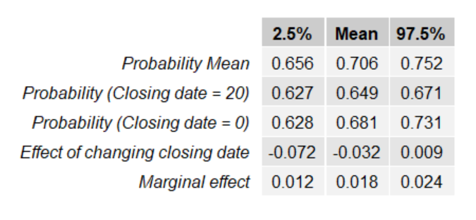
The predicted probability of voting is 71% indicating that a majority of people would vote on average holding all else constant. Changing the voter registration closing date has a small and insignificant effect on probability of voting as demonstrated by the confidence interval including zero.

